Lecture Notes 11: Split Plot ANOVA (Designs With One Between-Subjects Factor and One Within-Subjects Factor)
Josh Klugman
Split-Plot designs are a compromise between within-subject and between-subject designs. We get the benefits of the economy of the within-subject design (multiple data points per subject) without some of the drawbacks (differential carry-over, fatigue effects).
A terminological note: “Factor A” = the between-subjects factor “groups” = levels for the between-subjects factor “Factor B” = the within-subjects factor
But before diving into this technique, let’s review the assumption of compound symmetry for a one-way repeated measures ANOVA

Review of Compound Symmetry
Compound symmetry holds that the variances for each level of the factor are the same, and that the correlations between factors are the same.
tss<-data.frame(act=c(62,63,65,68,69,71,78,75),
cb=c(58,60,61,64,65,67,66,73),
ets=c(63,68,72,58,54,65,67,75),
tp=c(64,65,65,61,59,50,50,45))
tss
## act cb ets tp
## 1 62 58 63 64
## 2 63 60 68 65
## 3 65 61 72 65
## 4 68 64 58 61
## 5 69 65 54 59
## 6 71 67 65 50
## 7 78 66 67 50
## 8 75 73 75 45
cov(tss)
## act cb ets tp
## act 31.839285714 22.321428571 7.607142857 -40.23214286
## cb 22.321428571 22.214285714 8.785714286 -34.25000000
## ets 7.607142857 8.785714286 47.928571429 -16.96428571
## tp -40.232142857 -34.250000000 -16.964285714 62.55357143
Covariances are unstandardized correlations ranging from $−∞$ to $+∞$. The covariance of a variable with itself is just its variance. We will get a variance/covariance matrix from R to check out compound symmetry.
A covariance between two variables is denoted with $σ_{xx}$, where $xx$ represent the two different variables that covary. Example: $σ_{12}$ represents the covariance between variables 1 & 2 (note = this is the same as $σ_{21}$ )
The variance of one variable is denoted with $σ_{X}^{2}$ .
We often symbolize covariance-variance matrices with this kind of notation:
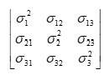
In fact, you only need one side of the diagonal to evaluate compound symmetry.
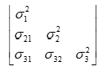
The assumption of compound symmetry for a within-subject factor with three levels or conditions can be expressed as:
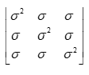
The lack of subscripts for the sigmas indicate that all of the variances are the same and all of the covariances are the same.
Subscripts imply that the variances and the covariances can differ.

Illustration
Let’s revisit the tachistoscope experiment. Subjects are told they will see either the letter “T” or the letter “I” displayed on the screen. In some trials, the letter appears dead center on the screen ( off-center) and in others it is off-center, or off-center. We are going to replace the noise factor with a between-subject age factor, with two levels: young and old.
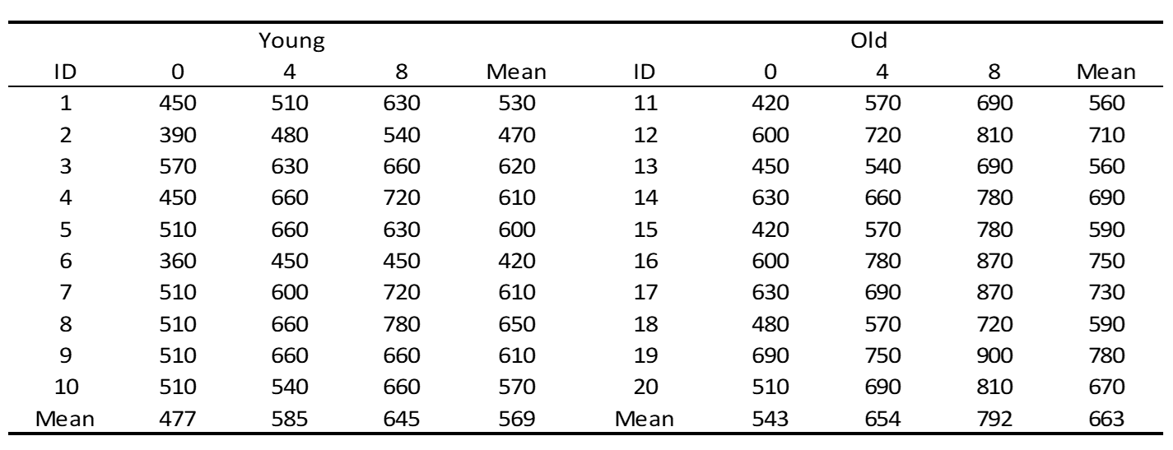
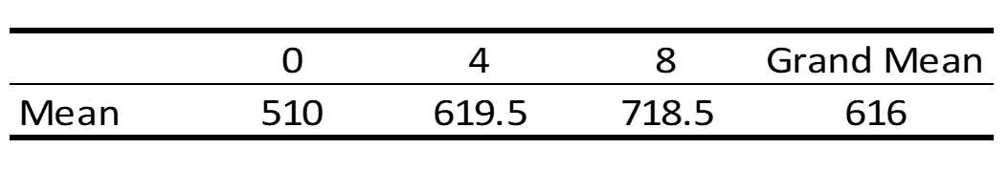
dfs<-data.frame(id=seq(1,20),
age=rep(c("Young","Old"),each=10),
a0=c(450,390,570,450,510,360,510,510,510,510,420,600,450,630,420,600,630,480,690,510),
a4=c(510,480,630,660,660,450,600,660,660,540,570,720,540,660,570,780,690,570,750,690),
a8=c(630,540,660,720,630,450,720,780,660,660,690,810,690,780,780,870,870,720,900,810))
dfs
## id age a0 a4 a8
## 1 1 Young 450 510 630
## 2 2 Young 390 480 540
## 3 3 Young 570 630 660
## 4 4 Young 450 660 720
## 5 5 Young 510 660 630
## 6 6 Young 360 450 450
## 7 7 Young 510 600 720
## 8 8 Young 510 660 780
## 9 9 Young 510 660 660
## 10 10 Young 510 540 660
## 11 11 Old 420 570 690
## 12 12 Old 600 720 810
## 13 13 Old 450 540 690
## 14 14 Old 630 660 780
## 15 15 Old 420 570 780
## 16 16 Old 600 780 870
## 17 17 Old 630 690 870
## 18 18 Old 480 570 720
## 19 19 Old 690 750 900
## 20 20 Old 510 690 810
dfs$age<-factor(dfs$age,levels=c("Young","Old"))

Graphing the Data
I first restructure the data so it is in “long” format and I create a summary dataframe of means for combination of angle and age.
ldf<-pivot_longer(dfs,cols=c("a0","a4","a8"),
names_to="angle",
values_to="latency")
ldf
## # A tibble: 60 × 4
## id age angle latency
## <int> <fct> <chr> <dbl>
## 1 1 Young a0 450
## 2 1 Young a4 510
## 3 1 Young a8 630
## 4 2 Young a0 390
## 5 2 Young a4 480
## 6 2 Young a8 540
## 7 3 Young a0 570
## 8 3 Young a4 630
## 9 3 Young a8 660
## 10 4 Young a0 450
## # ℹ 50 more rows
ldf<-group_by(ldf,age,angle)
Ms<-summarize(ldf,M=mean(latency))
## `summarise()` has grouped output by 'age'. You can override using the `.groups`
## argument.
ldf<-ungroup(ldf)
Ms
## # A tibble: 6 × 3
## # Groups: age [2]
## age angle M
## <fct> <chr> <dbl>
## 1 Young a0 477
## 2 Young a4 585
## 3 Young a8 645
## 4 Old a0 543
## 5 Old a4 654
## 6 Old a8 792
Then I create a subsetted version of the wide dataframe with just the condition variables and age grouping variable. Because the baguley.txt is finnicky with the grouping variables (which I believe have to be last in the dataframe), I convert it to a numeric 1,2 variable.
dfss<-dfs[c("a0","a4","a8","age")]
dfss$age<-ifelse(dfss$age=="Young",1,2)
dfss
## a0 a4 a8 age
## 1 450 510 630 1
## 2 390 480 540 1
## 3 570 630 660 1
## 4 450 660 720 1
## 5 510 660 630 1
## 6 360 450 450 1
## 7 510 600 720 1
## 8 510 660 780 1
## 9 510 660 660 1
## 10 510 540 660 1
## 11 420 570 690 2
## 12 600 720 810 2
## 13 450 540 690 2
## 14 630 660 780 2
## 15 420 570 780 2
## 16 600 780 870 2
## 17 630 690 870 2
## 18 480 570 720 2
## 19 690 750 900 2
## 20 510 690 810 2
I use the baguley.txt function cm.ci.mixed to produce the Cousineau-Morey confidence intervals for each combination of age and angle. I have to do some data wrangling because of how the function named the lower and upper bound variables for the old condition.
cmdf<-as.data.frame(cm.ci.mixed(dfss,difference=F))
cmdf$angle<-rownames(cmdf)
cmdf.young<-subset(cmdf,select=c("angle","lower","upper"))
cmdf.old<-subset(cmdf,select=c("angle","lower.1","upper.1"))
cmdf.old<-rename(cmdf.old,lower=lower.1,upper=upper.1)
cmdf.young$age<-"Young"
cmdf.old$age<-"Old"
cmdf.both<-rbind(cmdf.young,cmdf.old)
cmdf.both
## angle lower upper age
## a0 a0 446.1482896 507.8517104 Young
## a4 a4 557.8541140 612.1458860 Young
## a8 a8 612.6899331 677.3100669 Young
## a01 a0 512.9323088 573.0676912 Old
## a41 a4 632.7589987 675.2410013 Old
## a81 a8 768.4728405 815.5271595 Old
Combining the mean summary data frame and the Cousineau-Morey confidence interval data frame into one dataframe.
cmdf.merge<-merge(Ms,cmdf.both,by=c("angle","age"))
cmdf.merge$angle<-as.numeric(substr(cmdf.merge$angle,2,2))
cmdf.merge
## angle age M lower upper
## 1 0 Old 543 512.9323088 573.0676912
## 2 0 Young 477 446.1482896 507.8517104
## 3 4 Old 654 632.7589987 675.2410013
## 4 4 Young 585 557.8541140 612.1458860
## 5 8 Old 792 768.4728405 815.5271595
## 6 8 Young 645 612.6899331 677.3100669
The graph:
ggplot(data=cmdf.merge,aes(x=angle,y=M,color=age))+
geom_line(size=1)+
geom_point()+
geom_errorbar(aes(ymin=lower,ymax=upper,width=.2))+
labs(x="Angle (Degrees of Offset)",
y="Latency (ms)",
color="",
title="Latency By Subject Age Group and Letter Angle",
caption="Error Bars are Cousineau-Morey 95% confidence intervals.")+
scale_x_continuous(breaks=c(0,4,8))+
scale_color_manual(values=c("grey50","black"))+
theme(legend.position="bottom")
## Warning: Using `size` aesthetic for lines was deprecated in ggplot2 3.4.0.
## ℹ Please use `linewidth` instead.
## This warning is displayed once every 8 hours.
## Call `lifecycle::last_lifecycle_warnings()` to see where this warning was
## generated.
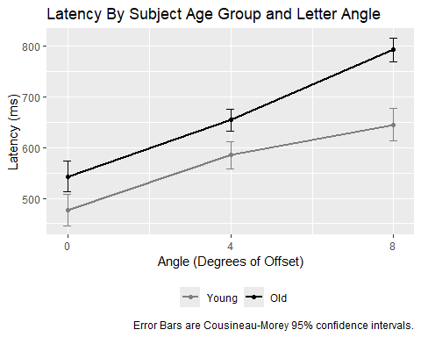

General Linear Model, Sources of Variation and ANOVA Table

GLM
$Y_{ijk}=\overline{Y}+\hat{α_{j}}+\hat{β_{k}}+\hat{π_{i}}+\hat{αβ_{jk}}+\hat{βπ_{ijk}}$
Factor A: The between-subjects factor (age)
Factor B: the within-subjects factor (angle)
i indexes subjects
j indexes levels of the between-subjects Factor A
k indexes levels of the within-subjects Factor B
$\hat{α_{j}}$ is the effect of being in level j of between-subject Factor A
$\hat{α_{j}}=\overline{Y_{j}}−\overline{Y}$
$\hat{π_{i}}$ is the effect of being subject i (we are not interested in this effect)
$\hat{π_{i}}=\overline{Y_{ij}}−\overline{Y_{j}}$
(note how the subject effect is calculated, because subject is nested within age)
$\hat{β_{k}}$ is the effect of being in level k of withn-subject factor B
$\hat{β_{k}}=\overline{Y_{k}}−\overline{Y}$
$\hat{αβ_{jk}}$ is the effect of being in level j of between-subject Factor A and level k of within-subject Factor B
$\hat{αβ_{jk}}={\overline{Y}}_{jk}−{\overline{Y}}_{j}−{\overline{Y}}_{k}+\overline{Y}$
$\hat{βπ_{ijk}}$ is the effect of being subject i and being in level k of Factor B
$\hat{βπ_{ijk}}=Y_{ijk}−{\overline{Y}}_{ij}−{\overline{Y}}_{jk}+{\overline{Y}}_{j}$

Sums of Squares

Main Effects of Age
$SSA=b\sum_{j=1}^{a}{n_{j}}{\left(\overline{Y_{j}}−\overline{Y}\right)}^{2}$

Main Effect of Subject
$SS_{subjet}=b\sum_{j=1}^{a}{\sum_{i=1}^{n}{{\left(\overline{Y_{ij}}−{\overline{Y}}_{j}\right)}^{2}}}=b\sum_{j=1}^{a}{\left(n_{j}−1\right)}s_{subjectmeans}^{2}$

Main Effect of Angle
$SSB=n\sum_{k=1}^{b}{{\left({\overline{Y}}_{k}−\overline{Y}\right)}^{2}}$

Calculating Main Effects
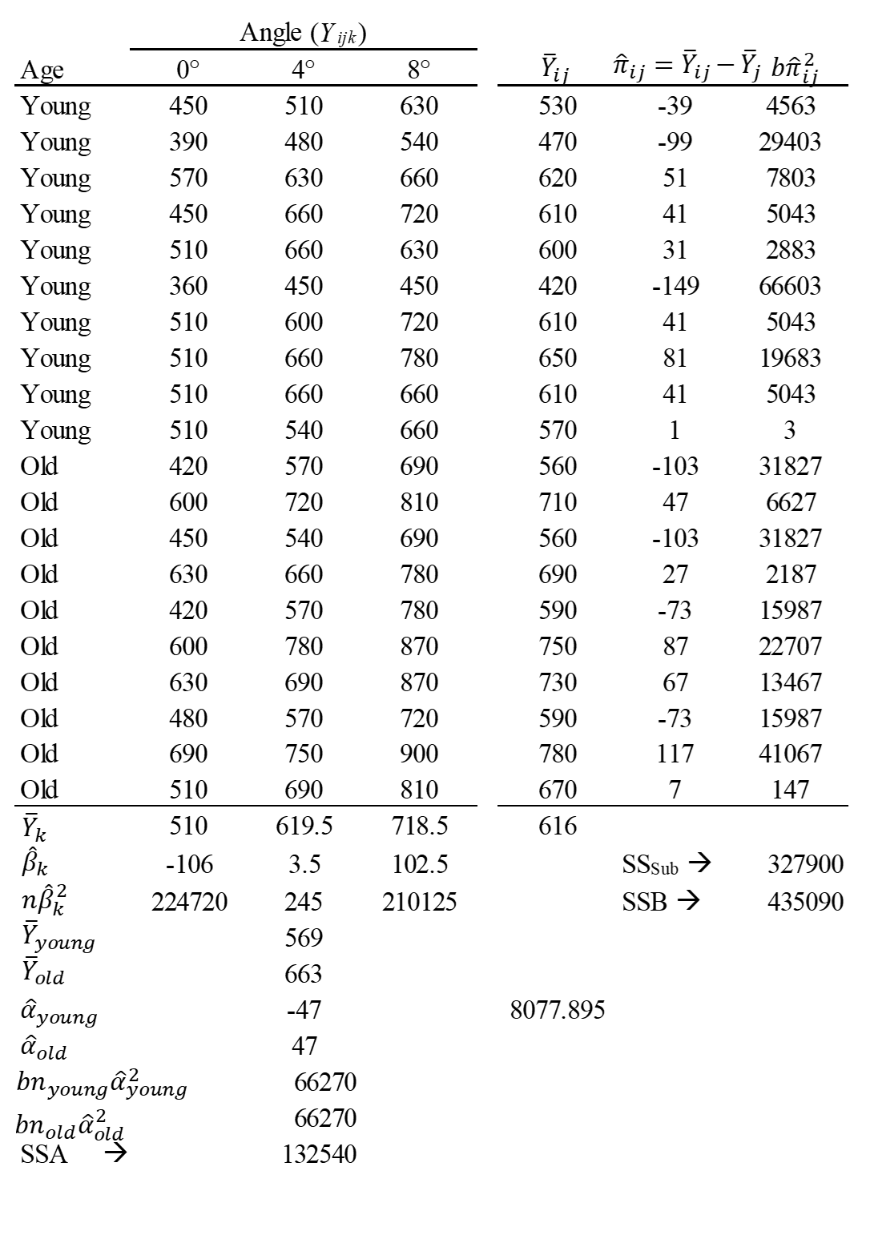

Interaction Between A & B
$SS\left(A×B\right)=\sum_{j=1}^{a}{\sum_{k=1}^{b}{n_{j}}}{\left({\overline{Y}}_{jk}−{\overline{Y}}_{j}−{\overline{Y}}_{k}+\overline{Y}\right)}^{2}$
Cell means:
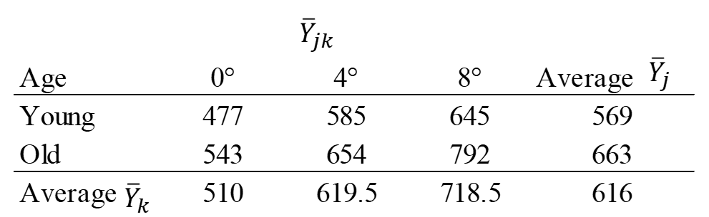
Interaction Effects
${\hat{αβ}}_{jk}={\overline{Y}}_{jk}−{\overline{Y}}_{j}−{\overline{Y}}_{k}+\overline{Y}$
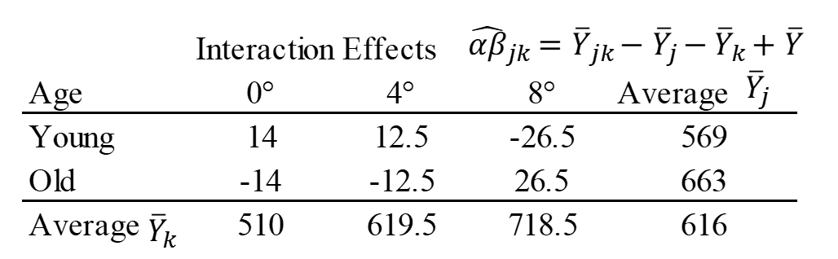
Sums of Squares $n_{j}\hat{αβ_{jk}^{2}}$
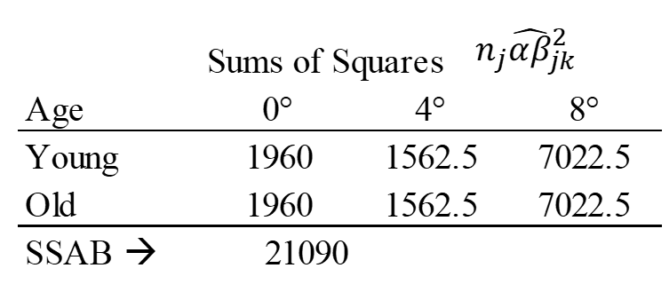

Interaction Between Factor B & Subject
$SS\left(B×S\right)=\sum_{k=1}^{b}{\sum_{j=1}^{a}{\sum_{i=1}^{n}{{\left(Y_{ijk}−\overline{Y_{ij}}−{\overline{Y}}_{jk}+{\overline{Y}}_{j}\right)}^{2}}}}$
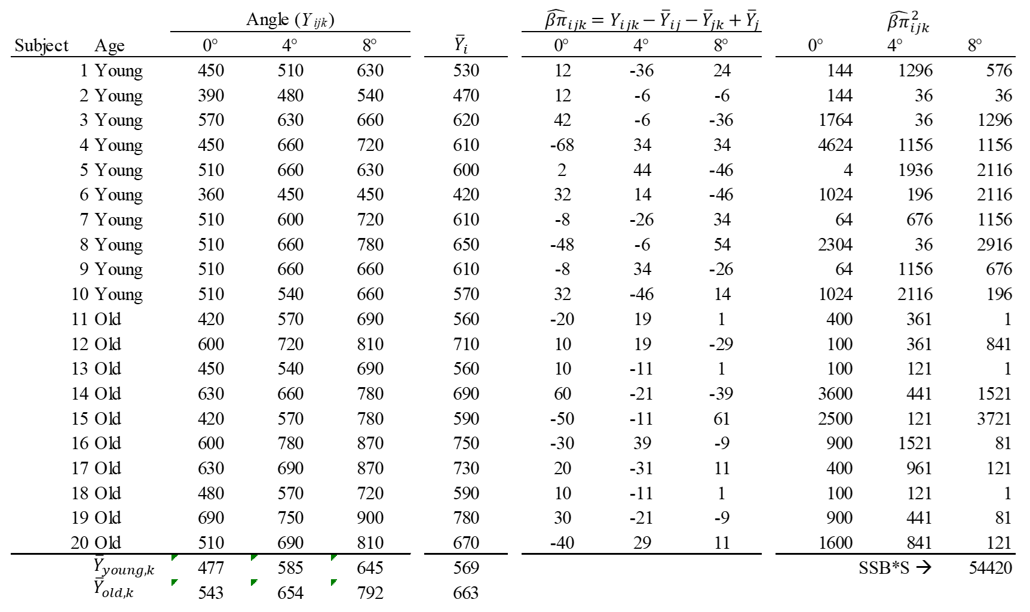
$SS\left(B×S\right)=54420$

Null hypotheses:
$H_{0}:α_{young}=α_{old}=0$
$H_{0}:β_{0}=β_{4}=β_{8}=0$
$H_{0}:αβ_{young,0}=αβ_{young,4}=αβ_{young,8}=αβ_{old,0}=αβ_{old,4}=αβ_{old,8}=0$

Sources of Variation in a Split-Plot ANOVA
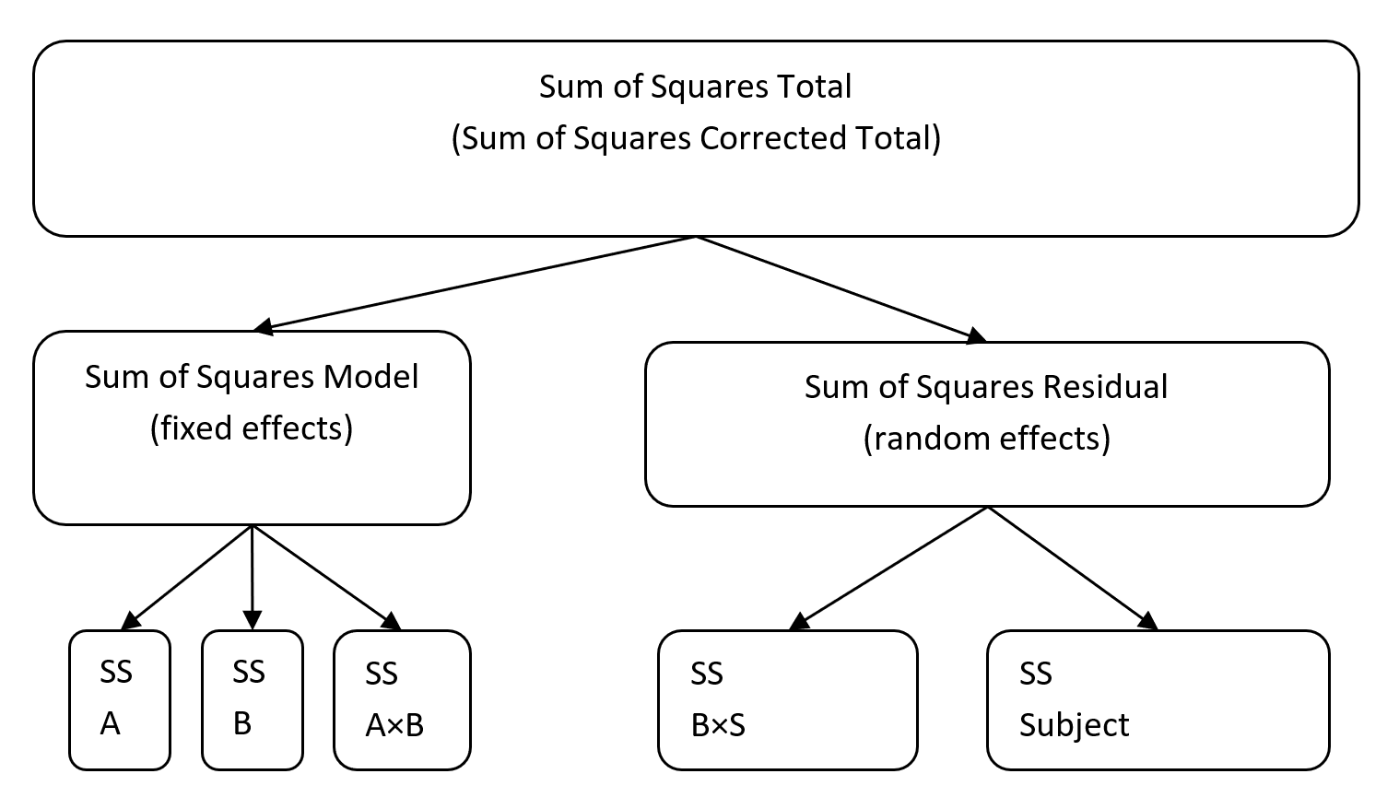

ANOVA Table
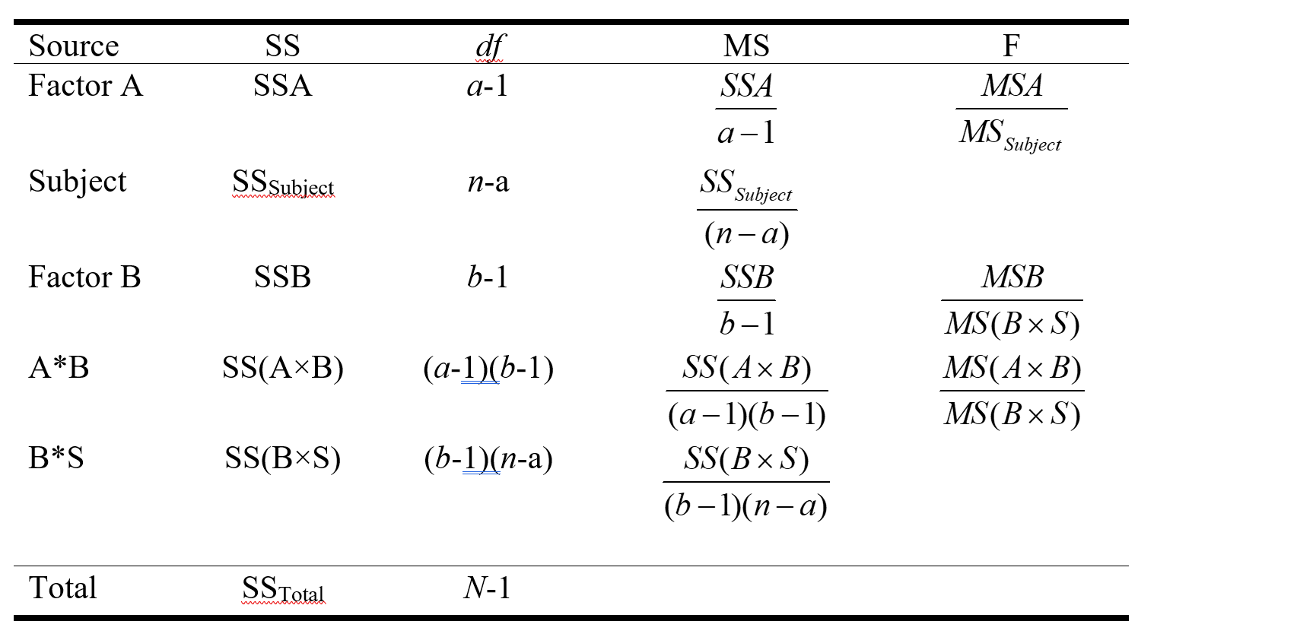
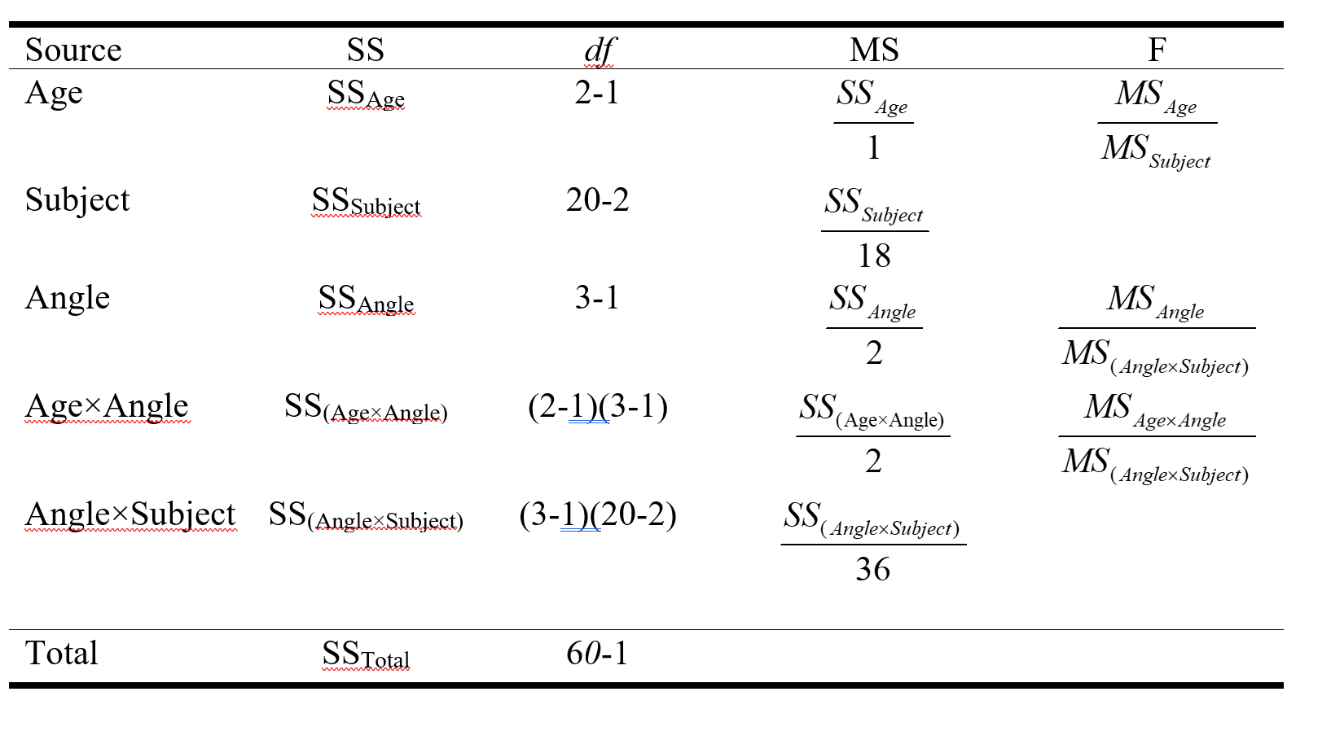
The subject effect is now the residual term for Factor A (between-subject factor). The subject effect is essentially the within-group variation for Factor A—it is capturing the variation going on within the age categories.
The angle×subject interaction effect is the residual term for Factor B and Factor A×B. The angle×subject interaction is capturing how the angle effect varies from subject to subject. Intuitively, it makes sense that it would be the residual term for Factor B.
It is not so intuitive why the angle×subject interaction effect is the residual term for A×B. Because the interaction involves a within-subject effect, the residual term has to come from a within-subject source of variance.
(plus, there is no A×B×S factor, because subject is nested in factor A)

Split-Plot ANOVA in R
m1<-aov_car(latency~age*angle+Error(id/angle),data=ldf)
## Contrasts set to contr.sum for the following variables: age
summary(m1)
## Warning in summary.Anova.mlm(object$Anova, multivariate = FALSE): HF eps > 1
## treated as 1
##
## Univariate Type III Repeated-Measures ANOVA Assuming Sphericity
##
## Sum Sq num Df Error SS den Df F value Pr(>F)
## (Intercept) 22767360 1 327900 18 1249.80933 < 0.000000000000000222
## age 132540 1 327900 18 7.27575 0.0147340
## angle 435090 2 54420 36 143.91069 < 0.000000000000000222
## age:angle 21090 2 54420 36 6.97574 0.0027515
##
## (Intercept) ***
## age *
## angle ***
## age:angle **
## ---
## Signif. codes: 0 '***' 0.001 '**' 0.01 '*' 0.05 '.' 0.1 ' ' 1
##
##
## Mauchly Tests for Sphericity
##
## Test statistic p-value
## angle 0.93683697 0.57430711
## age:angle 0.93683697 0.57430711
##
##
## Greenhouse-Geisser and Huynh-Feldt Corrections
## for Departure from Sphericity
##
## GG eps Pr(>F[GG])
## angle 0.94058952 < 0.000000000000000222 ***
## age:angle 0.94058952 0.0033994 **
## ---
## Signif. codes: 0 '***' 0.001 '**' 0.01 '*' 0.05 '.' 0.1 ' ' 1
##
## HF eps Pr(>F[HF])
## angle 1.046677106 0.000000000000000006728921246
## age:angle 1.046677106 0.002751523391096888891682593

Assumptions of Split-Plot ANOVA
- We always assume that the cases are randomly drawn from the population and are independently sampled.
- Normality assumption – each cell defined by Factors A and B are normally distributed
- Overall sphericity / compound symmetry – equality of variances and covariances overall
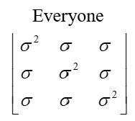
- Equality of variances and covariances across groups (Levene’s tests; Box test)
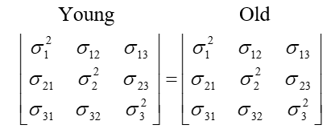
- Within group compound symmetry (we will not worry about this – you would use this if you were going to do repeated-measures ANOVAs on just young people or just old people
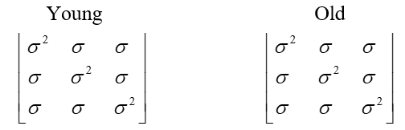
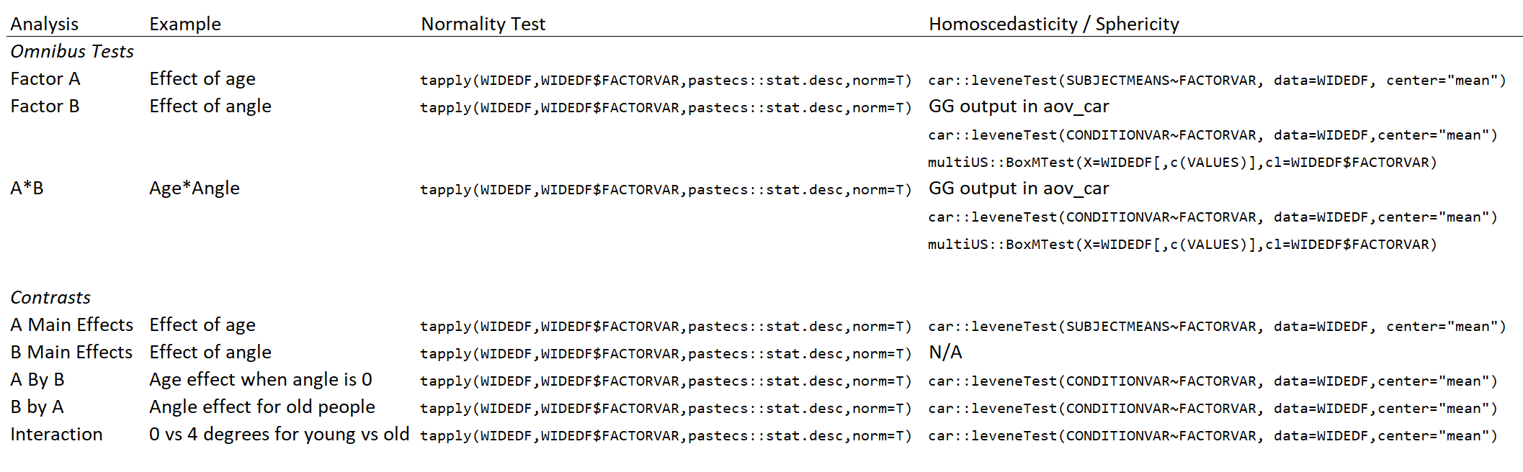
Table of Tests and Analytic Relevance; BS=between-subject; WS=within-subject
test | analysis
Cell-By-Cell Normality | All analyses
Sphericity | OMNIBUS tests of WS, WS*BS
Subject Mean Equality of Variances Across BS Factor | MAIN effects of BS factor
Condition Variable Equality of Variances Across BS Factor | WS, WS*BS (cell) analyses
Box Test for equality of covariance matrices across BS factor | OMNIBUS tests of WS, WS*BS

Testing the Assumptions

Normality For Each Cell
tapply(dfs,dfs$age,pastecs::stat.desc,norm=T)
## $Young
## id age a0 a4 a8
## nbr.val 10.0000000000 NA 10.0000000000 10.00000000000 10.0000000000
## nbr.null 0.0000000000 NA 0.0000000000 0.00000000000 0.0000000000
## nbr.na 0.0000000000 NA 0.0000000000 0.00000000000 0.0000000000
## min 1.0000000000 NA 360.0000000000 450.00000000000 450.0000000000
## max 10.0000000000 NA 570.0000000000 660.00000000000 780.0000000000
## range 9.0000000000 NA 210.0000000000 210.00000000000 330.0000000000
## sum 55.0000000000 NA 4770.0000000000 5850.00000000000 6450.0000000000
## median 5.5000000000 NA 510.0000000000 615.00000000000 660.0000000000
## mean 5.5000000000 NA 477.0000000000 585.00000000000 645.0000000000
## SE.mean 0.9574271078 NA 20.2237484162 26.17250465660 29.7489495613
## CI.mean.0.95 2.1658505897 NA 45.7492973382 59.20631887731 67.2967993358
## var 9.1666666667 NA 4090.0000000000 6850.00000000000 8850.0000000000
## std.dev 3.0276503541 NA 63.9531078213 82.76472678623 94.0744386111
## coef.var 0.5504818826 NA 0.1340736013 0.14147816545 0.1458518428
## skewness 0.0000000000 NA -0.5029051485 -0.41433074372 -0.6323877804
## skew.2SE 0.0000000000 NA -0.3659925275 -0.30153192216 -0.4602243639
## kurtosis -1.5616363636 NA -1.0483368105 -1.67833928286 -0.4935219764
## kurt.2SE -0.5852118431 NA -0.3928565775 -0.62894541131 -0.1849437629
## normtest.W 0.9701646112 NA 0.8820045721 0.84161910016 0.9255582758
## normtest.p 0.8923673075 NA 0.1375844583 0.04613886707 0.4056497409
##
## $Old
## id age a0 a4
## nbr.val 10.0000000000 NA 10.000000000000 10.0000000000000
## nbr.null 0.0000000000 NA 0.000000000000 0.0000000000000
## nbr.na 0.0000000000 NA 0.000000000000 0.0000000000000
## min 11.0000000000 NA 420.000000000000 540.0000000000000
## max 20.0000000000 NA 690.000000000000 780.0000000000000
## range 9.0000000000 NA 270.000000000000 240.0000000000000
## sum 155.0000000000 NA 5430.000000000000 6540.0000000000000
## median 15.5000000000 NA 555.000000000000 675.0000000000000
## mean 15.5000000000 NA 543.000000000000 654.0000000000000
## SE.mean 0.9574271078 NA 31.128764832547 27.1293199325011
## CI.mean.0.95 2.1658505897 NA 70.418158335007 61.3707854071514
## var 9.1666666667 NA 9690.000000000000 7360.0000000000000
## std.dev 3.0276503541 NA 98.437797618598 85.7904423581089
## coef.var 0.1953322809 NA 0.181285078487 0.1311780464191
## skewness 0.0000000000 NA 0.005434746947 0.0010262620852
## skew.2SE 0.0000000000 NA 0.003955172814 0.0007468689782
## kurtosis -1.5616363636 NA -1.772943956139 -1.7491605623819
## kurt.2SE -0.5852118431 NA -0.664397822961 -0.6554851695291
## normtest.W 0.9701646112 NA 0.904847558425 0.9061451274590
## normtest.p 0.8923673075 NA 0.247439417213 0.2555473955988
## a8
## nbr.val 10.00000000000
## nbr.null 0.00000000000
## nbr.na 0.00000000000
## min 690.00000000000
## max 900.00000000000
## range 210.00000000000
## sum 7920.00000000000
## median 795.00000000000
## mean 792.00000000000
## SE.mean 23.74868417408
## CI.mean.0.95 53.72325601142
## var 5640.00000000000
## std.dev 75.09993342207
## coef.var 0.09482314826
## skewness -0.06578468591
## skew.2SE -0.04787523758
## kurtosis -1.57373019466
## kurt.2SE -0.58974391810
## normtest.W 0.92540148713
## normtest.p 0.40421221811
ggplot(data=ldf,aes(x=latency,y=age,fill=angle))+
geom_boxplot()+
coord_flip()
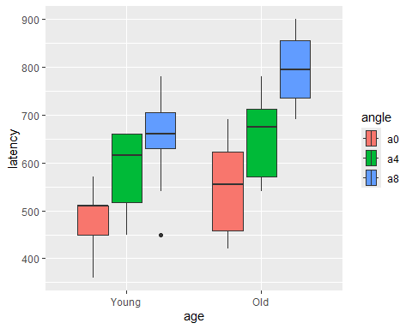
Normality assumption checks out, except for the young-4 degree angle condition.

Overall Sphericity
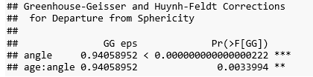
According to the Greenhouse-Geisser $\hat{ε}$ , we have moderate violations of sphericity. To play it safe, we should use the adjusted repeated-measures ANOVA output (although we possibly could get away with the unadjusted version).

Equality of Variances Averaging Across Levels of the Within-Subject Factor
dfs$pmean<-(dfs$a0+dfs$a4+dfs$a8)/3
car::leveneTest(pmean~age, data=dfs, center="mean")
## Levene's Test for Homogeneity of Variance (center = "mean")
## Df F value Pr(>F)
## group 1 0.56773 0.4609
## 18
We have homogeneity of variances.
Assuming normality is met, this means the following:
- We can do an omnibus test on the main effect of the between-subject factor
- When we do the main-effects contrasts for age we can assume equal variances

Equality of Variances for Each Level of the Within-Subject Factor
Null hypotheses for Levene’s test:
$H_{0}:σ_{0,young}^{2}=σ_{0,old}^{2}$
$H_{0}:σ_{4,young}^{2}=σ_{4,old}^{2}$
$H_{0}:σ_{8,young}^{2}=σ_{8,old}^{2}$
Again, we want insignificant tests (we want to retain these null hypotheses).
car::leveneTest(a0~age, data=dfs,center="mean")
## Levene's Test for Homogeneity of Variance (center = "mean")
## Df F value Pr(>F)
## group 1 5.19638 0.035046 *
## 18
## ---
## Signif. codes: 0 '***' 0.001 '**' 0.01 '*' 0.05 '.' 0.1 ' ' 1
car::leveneTest(a4~age, data=dfs,center="mean")
## Levene's Test for Homogeneity of Variance (center = "mean")
## Df F value Pr(>F)
## group 1 0.00577 0.9403
## 18
car::leveneTest(a8~age, data=dfs,center="mean")
## Levene's Test for Homogeneity of Variance (center = "mean")
## Df F value Pr(>F)
## group 1 0.06372 0.80357
## 18
The Levene’s test suggests that the “young, 0 degrees” variance is significantly different from the “old, 0 degrees” variance.
This means (assuming normality):
- The fact that the Levene’s test is significant at 0 degrees should make us weary of doing omnibus tests involving Angle—suggests we should not average across age groups. We should check out the Box’s test though.
- We should be careful about assuming equal variances when we do simple effects tests looking either at the effect of Factor A (age) within levels of Factor B (angle) or the effect of Factor B (angle) within levels of Factor A (age).
- We should probably not assume equal variances when doing interaction contrasts.

Equality of Covariance / Variance Matrices
We will ask multiUS::BoxMTest to produce Box’s test of the equality of covariance matrices and Levene’s test of equality of variances. I think it’d be easiest to use the wide dataframe. For the X argument I tell it to use the wide dataframe, specifically the third, fourth, and fifth columns (a0, a4, and a8). For the cl argument I specify the age variable (this variable MUST be a factor variable).
Null hypothesis for Box’s test:

We want an insignificant test result!
multiUS::BoxMTest(X=dfs[,c(3,4,5)],cl=dfs$age)
##
## ------------------------------------------------------------
## MBox F df1 df2 p
## ------------------------------------------------------------
## 5.9239 0.8065 6 2347.472 0.5647
## ------------------------------------------------------------
## Covariance matrices are not significantly different.
This means (assuming normality):
- We have evidence that we can pool the different age groups together to do omnibus tests of the within-subject factor (angle) and the interaction between the within-subject factor and the between-subject factor. We should check out the Levene’s test for equality of variances for each level of angle though (above).

If Assumptions Are Violated…

If data are non-normal…
- Robust tests (see work of Rand Wilcox)

If variances are not equal across the between-subject groups…
- Should use Welch’s V test for between-subject omnibus tests.
- Contrasts for between-subject factor would have to use contrast-specific error terms

Overall compound symmetry/sphericity
- For moderate violations, use epsilon-adjusted omnibus tests
- For severe violations, consider using MANOVA for omnibus tests
- You can still use contrasts testing main effect of within-subject factor, but they have to use a contrast-specific residual MS (which we have been doing by default anyway)

Equality of covariance/variance matrices across groups
- For omnibus F-test: use MANOVA
- You can still use simple effects contrasts, but they must use a contrast-specific residual MS (which we have been doing by default anyway)
For our example, we did find a significant violation of the assumption of homogenous variances for the 0 degrees level. This implies that any simple effects contrasts looking at the effect of age within angle 0 will have to drop the assumption of homogenous variances (use contrast-specific error terms).

Correcting for Heterogeneous Variances
We previously calculated the average latency for each subject (pmean). We will do a regular ANOVA and a Welch’s V test (which is the ANOVA equivalent for data violating the equal variances assumption).
# Vanilla ANOVA
summary(aov(pmean~age,data=dfs))
## Df Sum Sq Mean Sq F value Pr(>F)
## age 1 44180 44180.00 7.27575 0.014734 *
## Residuals 18 109300 6072.22
## ---
## Signif. codes: 0 '***' 0.001 '**' 0.01 '*' 0.05 '.' 0.1 ' ' 1
# Welch's V
oneway.test(pmean~age,data=dfs,var.equal=FALSE)
##
## One-way analysis of means (not assuming equal variances)
##
## data: pmean and age
## F = 7.2757548, num df = 1.000000, denom df = 17.788432, p-value =
## 0.01483957
For the omnibus F test, our conclusions do not change when we account for heterogeneous variances–the Welch’s V is significant as well.
Here is the output for the between-subject factor from the split-plot ANOVA:
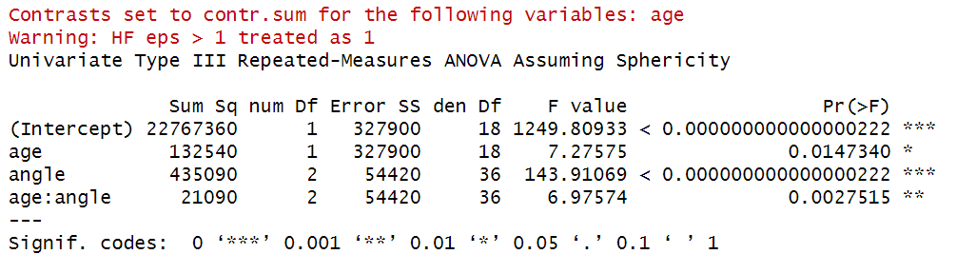
The point of this is to show you that the between-subjects ANOVA is the same as a regular oneway ANOVA (averaged across the within-subjects levels). The unadjusted F statistic is the exact same (7.276). The mean squares in the split-plot ANOVA are exactly three times the mean squares in the oneway ANOVA, because there are three within-subject levels in the split-plot ANOVA.
If the variances were unequal for young and old subjects, we could just use the Welch’s V output and forgo the between-subject ANOVA produced by aov_car.

Effect Sizes
$η_{P}^{2}=\frac{SS_{effect}}{SS_{effect}+SS_{errortermforeffect}}$
summary(m1)
## Warning in summary.Anova.mlm(object$Anova, multivariate = FALSE): HF eps > 1
## treated as 1
##
## Univariate Type III Repeated-Measures ANOVA Assuming Sphericity
##
## Sum Sq num Df Error SS den Df F value Pr(>F)
## (Intercept) 22767360 1 327900 18 1249.80933 < 0.000000000000000222
## age 132540 1 327900 18 7.27575 0.0147340
## angle 435090 2 54420 36 143.91069 < 0.000000000000000222
## age:angle 21090 2 54420 36 6.97574 0.0027515
##
## (Intercept) ***
## age *
## angle ***
## age:angle **
## ---
## Signif. codes: 0 '***' 0.001 '**' 0.01 '*' 0.05 '.' 0.1 ' ' 1
##
##
## Mauchly Tests for Sphericity
##
## Test statistic p-value
## angle 0.93683697 0.57430711
## age:angle 0.93683697 0.57430711
##
##
## Greenhouse-Geisser and Huynh-Feldt Corrections
## for Departure from Sphericity
##
## GG eps Pr(>F[GG])
## angle 0.94058952 < 0.000000000000000222 ***
## age:angle 0.94058952 0.0033994 **
## ---
## Signif. codes: 0 '***' 0.001 '**' 0.01 '*' 0.05 '.' 0.1 ' ' 1
##
## HF eps Pr(>F[HF])
## angle 1.046677106 0.000000000000000006728921246
## age:angle 1.046677106 0.002751523391096888891682593
var(dfs$pmean)
## [1] 8077.894737
$η_{P,age}^{2}=\frac{SS_{age}}{SS_{age}+SS_{subject}}=\frac{13540}{13540+327900}=.288$
$η_{P,angle}^{2}=\frac{SS_{angle}}{SS_{angle}+SS_{angle×subject}}=\frac{435090}{435090+54420}=.889$
$η_{P,angle×age}^{2}=\frac{SS_{angle×age}}{SS_{angle×age}+SS_{angle×subject}}=\frac{21090}{21090+54420}=.279$

Contrasts

Planned & Post-Hoc Adjustments
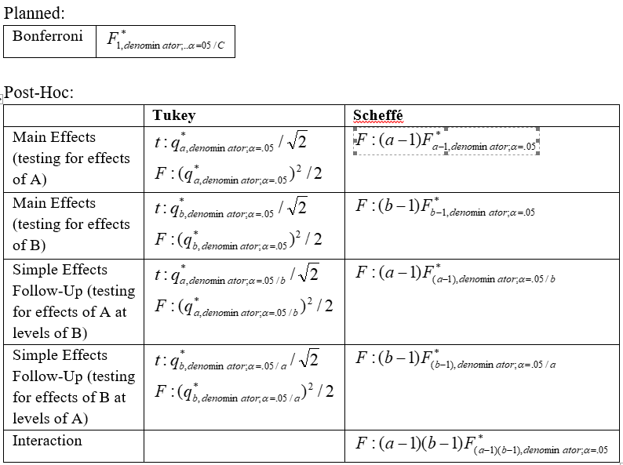
Note about denominator degrees of freedom for contrasts: usually the denominator degrees of freedom will be n – a (total number of subjects minus number of groups, assuming no adjustments for unequal variances).

Effect Sizes for Contrasts
I think probably the easiest and most straight-forward approach to effect sizes for split-plot ANOVA contrasts is to drop what we have been using thus far for repeated-measures designs: d_{z}, where the standardizer (the denominator) is the standard deviation of the difference variable. If we apply d_{z} to a split-plot ANOVA, we would end up with a variety of standardizers depending on the contrast.
Instead, let us switch to d_{av}, where we basically treat all the factors as between-subjects (that is, treat each observation as coming from a different subject). We can get a single standardizer for a variety of contrasts this way.
To do this, I will do a regular two-way ANOVA on the within-subject and between-subject factor, extract the MSW, and take the square root of it, to get the pooled SD.
# creating fake ID for observations in long data frame
ldf$fakeid<-seq(1:60)
summary(afex::aov_car(latency~age*angle+Error(fakeid),data=ldf))
## Converting to factor: angle
## Contrasts set to contr.sum for the following variables: age, angle
## Anova Table (Type 3 tests)
##
## Response: latency
## num Df den Df MSE F ges Pr(>F)
## age 1 54 7080 18.72034 0.25742920 0.0000657993153 ***
## angle 2 54 7080 30.72669 0.53227878 0.0000000012293 ***
## age:angle 2 54 7080 1.48941 0.05227932 0.23462
## ---
## Signif. codes: 0 '***' 0.001 '**' 0.01 '*' 0.05 '.' 0.1 ' ' 1
sqrt(7080)
## [1] 84.14273587
pooledsd<-sqrt(7080)
Our pooled SD, the square root of 7080, is 84.14, which we will use to standardize all contrasts.
Go back to our split-plot ANOVA sums of squares. The $SS_{SUBJECT}$ ($df_{SUBJECT}=n−a=20−2=18$) was 54,420, and the $SS_{B×SUBJECT}$ ($df_{B×SUBJECT}=\left(a−1\right)\left(n−a\right)=36$) was 327,900. If we add up these two sums of squares, we get 382,320, with a combined degrees of freedom of 54. The mean square of this combined residual is 382,320/54 = 7080.

Between-Subjects Main Effects Contrasts

Assuming Equal Variances
If we assume equal variances, we can use emmeans to carry out any kind of contrast.
For a main effects contrast on a between-subjects factor, this is equivalent to comparing differences for a person-mean (averaging across the within-subject levels; we have already done this in the form of dfs$pmean). In this case, we are comparing the overall subject mean latency of young subjects versus old subjects:
$H_{0}:α_{young}=α_{old}$
It is of course redundant to do such a contrast, since the factor has only two levels, and we could just rely on the omnibus test to do this for us.
# creating marginal means em object
em1.age<-emmeans::emmeans(m1,~age)
em1.age
## age emmean SE df lower.CL upper.CL
## Young 569 24.64187944 18 517.2293324 620.7706676
## Old 663 24.64187944 18 611.2293324 714.7706676
##
## Results are averaged over the levels of: angle
## Confidence level used: 0.95
# performing contrast (could also use pairs)
A.main.contrasts.list<-list(c(-1,1))
contrast(em1.age,A.main.contrasts.list)
## contrast estimate SE df t.ratio p.value
## c(-1, 1) 94 34.8488801 18 2.697 0.0147
##
## Results are averaged over the levels of: angle
pairs(em1.age)
## contrast estimate SE df t.ratio p.value
## Young - Old -94 34.8488801 18 -2.697 0.0147
##
## Results are averaged over the levels of: angle
summary(m1)
## Warning in summary.Anova.mlm(object$Anova, multivariate = FALSE): HF eps > 1
## treated as 1
##
## Univariate Type III Repeated-Measures ANOVA Assuming Sphericity
##
## Sum Sq num Df Error SS den Df F value Pr(>F)
## (Intercept) 22767360 1 327900 18 1249.80933 < 0.000000000000000222
## age 132540 1 327900 18 7.27575 0.0147340
## angle 435090 2 54420 36 143.91069 < 0.000000000000000222
## age:angle 21090 2 54420 36 6.97574 0.0027515
##
## (Intercept) ***
## age *
## angle ***
## age:angle **
## ---
## Signif. codes: 0 '***' 0.001 '**' 0.01 '*' 0.05 '.' 0.1 ' ' 1
##
##
## Mauchly Tests for Sphericity
##
## Test statistic p-value
## angle 0.93683697 0.57430711
## age:angle 0.93683697 0.57430711
##
##
## Greenhouse-Geisser and Huynh-Feldt Corrections
## for Departure from Sphericity
##
## GG eps Pr(>F[GG])
## angle 0.94058952 < 0.000000000000000222 ***
## age:angle 0.94058952 0.0033994 **
## ---
## Signif. codes: 0 '***' 0.001 '**' 0.01 '*' 0.05 '.' 0.1 ' ' 1
##
## HF eps Pr(>F[HF])
## angle 1.046677106 0.000000000000000006728921246
## age:angle 1.046677106 0.002751523391096888891682593

Dropping Equal Variances Assumption
If we were worried about the equal variances assumption, and we were doing a pair-wise contrast, we could use Welch’s t on the subject means (from the wide data frame). If this was a complex contrast we would either have to manually calculate the contrast (see Lecture Notes 7 on contrasts) or use a regression-based model that would adjust for heteroscedasticity.
# welch's t
t.test(pmean~age,data=dfs)
##
## Welch Two Sample t-test
##
## data: pmean by age
## t = -2.6973607, df = 17.788432, p-value = 0.01483957
## alternative hypothesis: true difference in means between group Young and group Old is not equal to 0
## 95 percent confidence interval:
## -167.27724764 -20.72275236
## sample estimates:
## mean in group Young mean in group Old
## 569 663

Cohen’s d and post-hoc adjustment
# getting Cohen's d
94/pooledsd
## [1] 1.117149318
Cohen’s d: $\frac{94}{84.14}=1.12$
Tukey post-hoc adjustment (redundant, it will resolve to a regular t critical value):
qtukey(1-.05,2,18)/sqrt(2)
## [1] 2.10092196
qt(.05/(2),18)
## [1] -2.10092204

Write-Up (assuming equal variances)
Older subjects had higher latency than younger subjects, t(18) = -2.70, p = .015, $d_{av}$ = 1.12.

Within-Subjects Main Effects
We will test two pairwise contrasts:
$H_{0}:\left(−1\right)β_{0}+\left(1\right)β_{4}=0$
$H_{0}:\left(−1\right)β_{0}+\left(1\right)β_{8}=0$
When you are dealing with a purely within-subjects contrast, you do not have to worry about homoscedasticity (or sphericity for that matter).

Mechanics (using emmeans)
em1.angle<-emmeans::emmeans(m1,~angle)
em1.angle
## angle emmean SE df lower.CL upper.CL
## a0 510.0 18.56071119 18 471.0053928 548.9946072
## a4 619.5 18.84807682 18 579.9016600 659.0983400
## a8 718.5 19.03286631 18 678.5134317 758.4865683
##
## Results are averaged over the levels of: age
## Confidence level used: 0.95
contrast.4v0<-c(-1,1,0)
contrast.8v0<-c(-1,0,1)
B.main.contrasts.list<-list(contrast.4v0,contrast.8v0)
contrast(em1.angle,B.main.contrasts.list)
## contrast estimate SE df t.ratio p.value
## c(-1, 1, 0) 109.5 12.09338662 18 9.055 <0.0001
## c(-1, 0, 1) 208.5 13.64734406 18 15.278 <0.0001
##
## Results are averaged over the levels of: age
# because this is a main effects contrast it is OK to use Tukey adjustment in the pairs function (as opposed to doing the Tukey adjustment yourself)
pairs(em1.angle,adjust="tukey")
## contrast estimate SE df t.ratio p.value
## a0 - a4 -109.5 12.09338662 18 -9.055 <0.0001
## a0 - a8 -208.5 13.64734406 18 -15.278 <0.0001
## a4 - a8 -99.0 11.00000000 18 -9.000 <0.0001
##
## Results are averaged over the levels of: age
## P value adjustment: tukey method for comparing a family of 3 estimates

Cohen’s d and Tukey critical t*
# Cohen's d
# take value of psi-hat and divide into it the standardizer
# 4 vs 0
109.5/pooledsd
## [1] 1.30136011
# 8 vs 0
208.5/pooledsd
## [1] 2.477932264
# manually getting Tukey t:
qtukey(1-.05,3,18)/sqrt(2)
## [1] 2.552163148

Write-Up
Latency is significantly higher at 4 degrees (M=620 ms) than at 0 degrees (M=510 ms), averaging across age groups, t(18)=9.05, Tukey adjusted p <.05, $d_{av}$=1.30. It is also higher at 8 degrees (M=719 ms) than at 0 degrees, t(18)=15.28, Tukey adjusted p < .05, $d_{av}$=2.48.

Simple Effects: Effect of A (Between-Subjects Factor) At One Level of B (wihin-Subjects Factor)
We want to know if age has a significant effect when the letter appears dead-center.
$H_{0}:αβ_{0,young}=αβ_{0,old}$
We want to know if age has a significant effect when the letter appears 4 degrees off-center.
$H_{0}:αβ_{4,young}=αβ_{4,old}$
We want to know if age has a significant effect when the letter appears 8 degrees off-center.
$H_{0}:αβ_{8,young}=αβ_{8,old}$
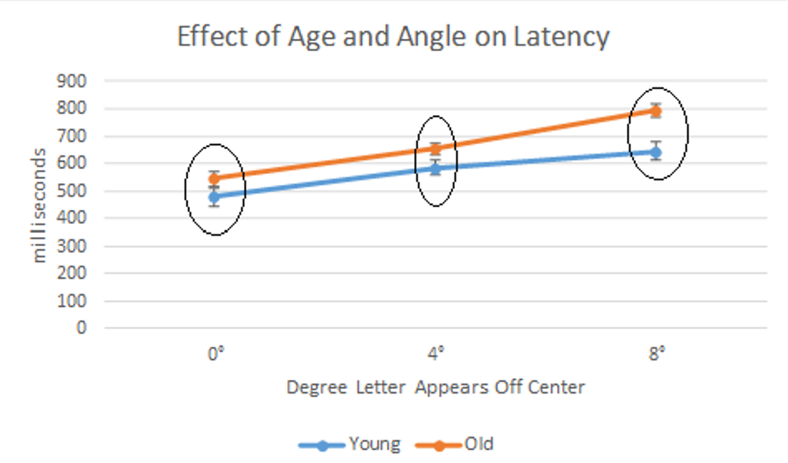

Age Effects at 0 degrees, dropping assumption of equal variances
We actually rejected null hypothesis that latency at 0 degrees has the same variance between older and younger subjects, so we should use a Welch’s t-test for this contrast. This will ONLY WORK for pairwise contrasts. For complex contrasts where you reject the equal variances assumption you need to manually calculate the contrast. Ugh.
t.test(a0~age,data=dfs,var.equal=FALSE)
##
## Welch Two Sample t-test
##
## data: a0 by age
## t = -1.7779491, df = 15.44866, p-value = 0.09509749
## alternative hypothesis: true difference in means between group Young and group Old is not equal to 0
## 95 percent confidence interval:
## -144.92277041 12.92277041
## sample estimates:
## mean in group Young mean in group Old
## 477 543

Age Effects at 4 and 8 degrees, assuming equal variances
If you assume equal variances, you can use emmeans for your contrast.
em1.cell<-emmeans::emmeans(m1,~angle*age)
pairs(em1.cell,simple="age")
## angle = a0:
## contrast estimate SE df t.ratio p.value
## Young - Old -66 37.12142239 18 -1.778 0.0923
##
## angle = a4:
## contrast estimate SE df t.ratio p.value
## Young - Old -69 37.69615365 18 -1.830 0.0838
##
## angle = a8:
## contrast estimate SE df t.ratio p.value
## Young - Old -147 38.06573262 18 -3.862 0.0011
# Cohen's d young v old at 4 degrees
69/pooledsd
## [1] 0.8200351377
# Cohen's d young v old at 8 degrees
147/pooledsd
## [1] 1.74703138

Cohen’s d and Bonferroni correction
# old vs young, 0 degrees
66/pooledsd
## [1] 0.7843814361
# old vs young, 4 degrees
69/pooledsd
## [1] 0.8200351377
# old vs young, 8 degrees
147/pooledsd
## [1] 1.74703138
# Bonferroni-corrected crit value--b/c age has only two levels, Tukey tcrit resolves to regular tcrit.
qtukey(1-.05/3,2,18)/sqrt(2)
## [1] 2.639144817
abs(qt(.05/(2*3),18))
## [1] 2.639144819

Write-Up
Because the variances of latencies at the 0 degree condition are significantly different between younger and older subjects, we used a Welch’s t test to compare the mean latencies of those groups (M= 477 and 543 ms, respectively), finding a non-significant difference, t(15.45)=1.77, p=0.10, d_{av}=0.78. Our diagnostics suggest equal variances between the two groups at at the 4 and 8 degree conditions, so we use regular contrasts for those conditions. As with the 0 degree condition, older subjects have longer latencies in the 4 and 8 degree conditions (Ms= 585 vs 654 for 4 degrees, d_{av}=0.82, and 645 v 792 for 8 degrees, d_{av}=1.75), but only the difference at 8 degrees is significant, surviving a Bonferroni adjustment to keep the familywise error rate at 0.05, t(18)=3.86, Bonferroni-adjusted p<.0.05.

Simple Effects of B (Within-Sujects Factor) at One Level of A (Between-Subjects Factor)
Let us say we were interested in testing a pairwise difference between 0 and 8 degrees, and a complex contrast comparing 4 degrees to 0 and 8 degrees.
$H_{0}:\left(−1\right)αβ_{0,young}+\left(0\right)β_{4,young}+\left(1\right)β_{8,young}=0$
$H_{0}:\left(−1\right)αβ_{0,old}+\left(0\right)β_{4,old}+\left(1\right)β_{8,old}=0$
$H_{0}:\left(1\right)αβ_{0,young}+\left(−2\right)β_{4,young}+\left(1\right)β_{8,young}=0$
$H_{0}:\left(1\right)αβ_{0,old}+\left(−2\right)β_{4,old}+\left(1\right)β_{8,old}=0$
(these are actually trend contrasts, with the pairwise contrast testing for a linear trend and the complex contrast testing for a quadratic trend).

Assuming Equal Variances (emmeans)

Dropping the equality of variances assumption
If we drop the equal variances assumption, we will construct difference variables capturing the contrast and then do dependent-samples t tests on them.
dfs$a8va0<- -1*dfs$a0 + 0*dfs$a4 + 1*dfs$a8
dfs$a4va08<- 2*dfs$a4 + -1*dfs$a0 + -1*dfs$a8
tapply(dfs$a8va0, dfs$age, t.test,mu=0)
## $Young
##
## One Sample t-test
##
## data: X[[i]]
## t = 8.1588012, df = 9, p-value = 0.00001891159
## alternative hypothesis: true mean is not equal to 0
## 95 percent confidence interval:
## 121.4193331 214.5806669
## sample estimates:
## mean of x
## 168
##
##
## $Old
##
## One Sample t-test
##
## data: X[[i]]
## t = 13.897825, df = 9, p-value = 0.0000002184787
## alternative hypothesis: true mean is not equal to 0
## 95 percent confidence interval:
## 208.4701226 289.5298774
## sample estimates:
## mean of x
## 249
tapply(dfs$a4va08, dfs$age, t.test,mu=0)
## $Young
##
## One Sample t-test
##
## data: X[[i]]
## t = 1.6329932, df = 9, p-value = 0.1369041
## alternative hypothesis: true mean is not equal to 0
## 95 percent confidence interval:
## -18.4935692 114.4935692
## sample estimates:
## mean of x
## 48
##
##
## $Old
##
## One Sample t-test
##
## data: X[[i]]
## t = -1.173913, df = 9, p-value = 0.2705574
## alternative hypothesis: true mean is not equal to 0
## 95 percent confidence interval:
## -79.02961474 25.02961474
## sample estimates:
## mean of x
## -27

Cohen’s d & Bonferroni-Tukey critical value
# Getting Cohen's d
mean(dfs$a8va0[dfs$age=="Young"])/pooledsd
## [1] 1.996607292
mean(dfs$a8va0[dfs$age=="Old"])/pooledsd
## [1] 2.959257236
# note adjustment for complex contrast--halving the contrast value.
(mean(dfs$a4va08[dfs$age=="Young"])*2/4)/pooledsd
## [1] 0.2852296131
(mean(dfs$a4va08[dfs$age=="Old"])*2/4)/pooledsd
## [1] -0.1604416574
# getting tukey critical value with bonferroni adjustment
qtukey(1-.05/2,3,9)/sqrt(2)
## [1] 3.23727877
# getting scheffe critical value with bonferroni adjustment
sqrt((3-1)*qf(1-.05/2,2,9))
## [1] 3.380741157
We see significant greater latency at 8 degrees than at 0 degrees for both the young and old subjects, t(9)=8.16, $d_{av}$=2.20, and t(9)=13.90, $d_{av}$=2.96, respectively, and both survive a Tukey adjustment meant to maintain the family-wise error rate at .05, both adjusted ps<.05. There are no significant differences between 4 degrees, on the one hand, and 0 and 8 degrees on the other, all unadjusted ps>0.14.

Interaction Contrasts
Let us say we are interested in whether or not the difference between 0 degrees and 8 degrees is the same for young people as it is for old people.
$H_{0}:αβ_{0,young}−αβ_{8,young}=αβ_{0,old}−αβ_{8,old}$
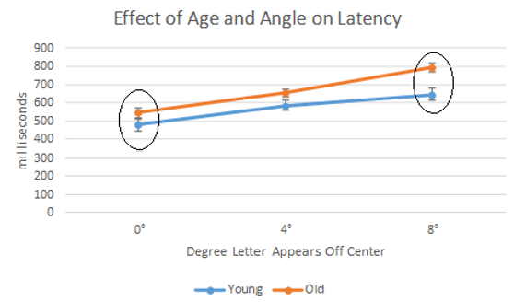

Assuming Equal Variances

Not Assuming Equal Variances
# not assuming equal variances (perferred)
t.test(a8va0~age,data=dfs)
##
## Welch Two Sample t-test
##
## data: a8va0 by age
## t = -2.9676104, df = 17.662393, p-value = 0.008369684
## alternative hypothesis: true difference in means between group Young and group Old is not equal to 0
## 95 percent confidence interval:
## -138.42268076 -23.57731924
## sample estimates:
## mean in group Young mean in group Old
## 168 249

Scheffe Adjustment
# Scheffe adjustment
sqrt((2-1)*(3-1)*qf(1-.05,2,17.66))
## [1] 2.670806521
Pasting interpretation of 0 vs 8 degree contrasts from previous section:
We see significant greater latency at 8 degrees than at 0 degrees for both the young and old subjects, t(9)=8.16, d_{av}=2.20, and t(9)=13.90, d_{av}=2.96, respectively, and both survive a Tukey adjustment meant to maintain the family-wise error rate at .05, both adjusted ps<.05.
Interaction contrast write-up:
According to a Scheffe-adjusted contrast, the latency difference between the 0 and 8 degrees conditions are significantly stronger for older people than for younger people, t(17.66) = 2.97, p<.05.

Another Example of Split-Plot ANOVA
c<-read_sav("split_plot_anova_chol.sav")
c$id<-rownames(c)
colnames(c)
## [1] "sex" "tc1" "tc2" "tc3" "tc4" "tc_mean" "id"
c$sex<-factor(c$sex,labels=c("Male","Female"))
cl<-pivot_longer(c,
cols=c("tc1","tc2","tc3","tc4"),
names_to="obs",
values_to="chol")
cl$seasonnum<-as.numeric(substr(cl$obs,3,3))
cl$seasonnum<-ifelse(cl$sex=="Male",cl$seasonnum+.5,cl$seasonnum)
cl$season<-factor(cl$obs,labels=c("Winter","Spring","Summer","Fall"))
Looking at the effect of gender and seasons on cholesterol. Subjects were volunteers recruited from a large HMO in Massachusetts. During each season (winter, spring, summer, fall) researchers recorded the subjects’ total cholesterol level. There were 220 men and 211 women in the data.
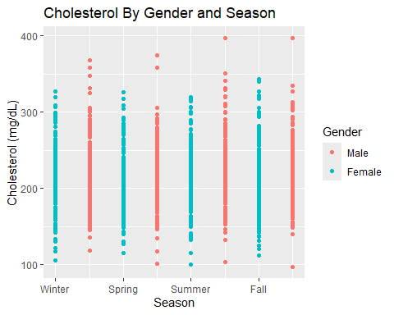
cl<-group_by(cl,sex,obs)
cls<-summarize(cl,M=mean(chol))
## `summarise()` has grouped output by 'sex'. You can override using the `.groups`
## argument.
cl<-ungroup(cl)
cmc<-as.data.frame(cm.ci.mixed(c[c("tc1","tc2","tc3","tc4","sex")]))
cmc$obs<-rownames(cmc)
cmc.male<-subset(cmc,select=c("obs","lower","upper"))
cmc.male$sex<-"Male"
cmc.female<-subset(cmc,select=c("obs","lower.1","upper.1"))
cmc.female<-rename(cmc.female,lower=lower.1,upper=upper.1)
cmc.female$sex<-"Female"
cmc.both<-rbind(cmc.male,cmc.female)
cmc.both$sex<-factor(cmc.both$sex)
gdf<-merge(cmc.both,cls,by=c("sex","obs"))
gdf
## sex obs lower upper M
## 1 Female tc1 214.8902716 217.9438516 216.4170616
## 2 Female tc2 211.9175914 214.5231669 213.2203791
## 3 Female tc3 212.5544375 215.6303967 214.0924171
## 4 Female tc4 213.4463755 216.7431980 215.0947867
## 5 Male tc1 222.5045477 225.6136341 224.0590909
## 6 Male tc2 217.3824841 220.2538795 218.8181818
## 7 Male tc3 220.6903741 223.6368986 222.1636364
## 8 Male tc4 221.0912051 223.9451585 222.5181818
gdf$season<-factor(gdf$obs,labels=c("Winter","Spring","Summer","Fall"))
ggplot(data=gdf,aes(x=season,y=M,color=sex,group=sex))+
geom_line()+
geom_errorbar(aes(ymin=lower,ymax=upper),width=.2)+
labs(title="Cholesterol By Gender and Season",
y="Cholesterol (mg/dl",x="Season",caption="Error bars represent COusineau-Morey 95% confidence intervals")
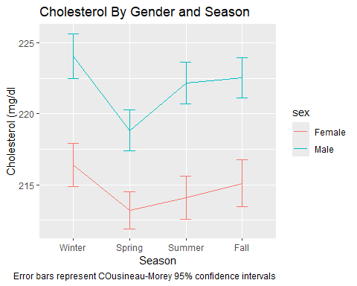

Testing Assumptions

Normality
tapply(c,c$sex,stat.desc,norm=T)
## $Male
## sex tc1 tc2 tc3
## nbr.val NA 220.000000000000 220.000000000000 220.0000000000000
## nbr.null NA 0.000000000000 0.000000000000 0.0000000000000
## nbr.na NA 0.000000000000 0.000000000000 0.0000000000000
## min NA 118.000000000000 101.000000000000 103.0000000000000
## max NA 368.000000000000 374.000000000000 397.0000000000000
## range NA 250.000000000000 273.000000000000 294.0000000000000
## sum NA 49293.000000000000 48140.000000000000 48876.0000000000000
## median NA 218.000000000000 218.250000000000 217.5000000000000
## mean NA 224.059090909091 218.818181818182 222.1636363636364
## SE.mean NA 2.750294266373 2.704420482617 2.8047194152269
## CI.mean NA 5.420432216149 5.330021623222 5.5276963128764
## var NA 1664.106081361561 1609.055832295558 1730.6192195931922
## std.dev NA 40.793456354685 40.113038183308 41.6007117678675
## coef.var NA 0.182065615768 0.183316751149 0.1872525695419
## skewness NA 0.578324909380 0.468365321788 0.7157075681707
## skew.2SE NA 1.762827005159 1.427652560242 2.1815913658636
## kurtosis NA 0.772421204669 1.389492629201 1.4172688989089
## kurt.2SE NA 1.182401358835 2.126997502048 2.1695166597911
## normtest.W NA 0.978329546360 0.979435795415 0.9708013987146
## normtest.p NA 0.001836050261 0.002685496457 0.0001625828016
## tc4 tc_mean id
## nbr.val 220.000000000000 220.000000000000 NA
## nbr.null 0.000000000000 0.000000000000 NA
## nbr.na 0.000000000000 0.000000000000 NA
## min 97.000000000000 104.750000000000 NA
## max 397.000000000000 377.500000000000 NA
## range 300.000000000000 272.750000000000 NA
## sum 48954.000000000000 48816.290000000001 NA
## median 221.000000000000 219.755000000000 NA
## mean 222.518181818182 221.892227272727 NA
## SE.mean 2.690611906222 2.580213299837 NA
## CI.mean 5.302806916321 5.085227230401 NA
## var 1592.666334578663 1464.650147984641 NA
## std.dev 39.908223896569 38.270747941275 NA
## coef.var 0.179348148410 0.172474486428 NA
## skewness 0.461764949245 0.531736452212 NA
## skew.2SE 1.407533566965 1.620817921523 NA
## kurtosis 1.237220396247 1.146633761278 NA
## kurt.2SE 1.893903311897 1.755235756381 NA
## normtest.W 0.982086686117 0.981359406997 NA
## normtest.p 0.006853771199 0.005281310711 NA
##
## $Female
## sex tc1 tc2 tc3
## nbr.val NA 211.00000000000 211.0000000000 211.0000000000
## nbr.null NA 0.00000000000 0.0000000000 0.0000000000
## nbr.na NA 0.00000000000 0.0000000000 0.0000000000
## min NA 106.00000000000 115.5000000000 100.0000000000
## max NA 327.00000000000 326.0000000000 320.0000000000
## range NA 221.00000000000 210.5000000000 220.0000000000
## sum NA 45664.00000000000 44989.5000000000 45173.5000000000
## median NA 216.50000000000 213.0000000000 212.0000000000
## mean NA 216.41706161137 213.2203791469 214.0924170616
## SE.mean NA 2.94987194554 2.7835274976 2.8280019984
## CI.mean NA 5.81515570314 5.4872367687 5.5749104547
## var NA 1836.06808846761 1634.8333446175 1687.4926088919
## std.dev NA 42.84936508827 40.4330724113 41.0791018511
## coef.var NA 0.19799439457 0.1896304311 0.1918755574
## skewness NA 0.08870872946 0.2620590048 0.1641362350
## skew.2SE NA 0.26488527920 0.7825111811 0.4901126721
## kurtosis NA -0.23582377879 -0.2236938522 -0.1638554460
## kurt.2SE NA -0.35369590200 -0.3355030575 -0.2457555386
## normtest.W NA 0.99528164572 0.9908555466 0.9939673971
## normtest.p NA 0.75876692976 0.2049080681 0.5538727261
## tc4 tc_mean id
## nbr.val 211.0000000000 211.0000000000 NA
## nbr.null 0.0000000000 0.0000000000 NA
## nbr.na 0.0000000000 0.0000000000 NA
## min 112.0000000000 114.8800000000 NA
## max 343.0000000000 320.0000000000 NA
## range 231.0000000000 205.1200000000 NA
## sum 45385.0000000000 45303.5000000000 NA
## median 213.0000000000 214.2500000000 NA
## mean 215.0947867299 214.7085308057 NA
## SE.mean 2.9588984798 2.7242194232 NA
## CI.mean 5.8329499339 5.3703212912 NA
## var 1847.3219250733 1565.9093792598 NA
## std.dev 42.9804830717 39.5715728682 NA
## coef.var 0.1998211287 0.1843036824 NA
## skewness 0.3740015845 0.1735780855 NA
## skew.2SE 1.1167730024 0.5183061457 NA
## kurtosis 0.1786247596 -0.1667240747 NA
## kurt.2SE 0.2679070184 -0.2500579979 NA
## normtest.W 0.9884962393 0.9944866127 NA
## normtest.p 0.0879079516 0.6342334257 NA
ggplot(data=cl,aes(x=sex,y=chol,fill=season))+
geom_boxplot()
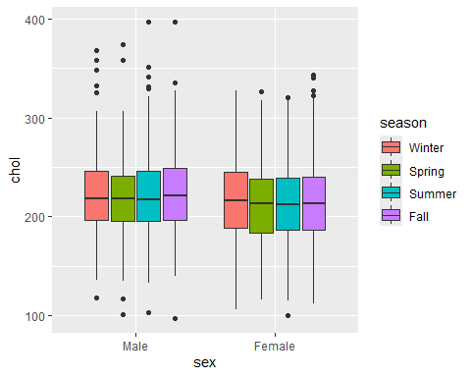
The distributions are more or less symmetrical, but we see that men have some positive outliers that result in significant levels of skewness and violations of normality. We should consider the use of robust statistical analyses.

SPhericity
m3<-aov_car(chol~sex*season+Error(id/season),data=cl)
## Contrasts set to contr.sum for the following variables: sex
summary(m3)
##
## Univariate Type III Repeated-Measures ANOVA Assuming Sphericity
##
## Sum Sq num Df Error SS den Df F value
## (Intercept) 82119677 1 2598411.69 429 13558.02911
## sex 22232 1 2598411.69 429 3.67048
## season 3982 3 317410.66 1287 5.38244
## sex:season 385 3 317410.66 1287 0.51972
## Pr(>F)
## (Intercept) < 0.000000000000000222 ***
## sex 0.0560486 .
## season 0.0011059 **
## sex:season 0.6687652
## ---
## Signif. codes: 0 '***' 0.001 '**' 0.01 '*' 0.05 '.' 0.1 ' ' 1
##
##
## Mauchly Tests for Sphericity
##
## Test statistic p-value
## season 0.96807998 0.016419837
## sex:season 0.96807998 0.016419837
##
##
## Greenhouse-Geisser and Huynh-Feldt Corrections
## for Departure from Sphericity
##
## GG eps Pr(>F[GG])
## season 0.97951591 0.0012088 **
## sex:season 0.97951591 0.6649819
## ---
## Signif. codes: 0 '***' 0.001 '**' 0.01 '*' 0.05 '.' 0.1 ' ' 1
##
## HF eps Pr(>F[HF])
## season 0.9870059143 0.00117009467
## sex:season 0.9870059143 0.66637435173
We meet the overall compound symmetry assumption required to do an omnibus F test looking at the main effects of season.

Equality of Variances
c$tc_mean<-(c$tc1+c$tc2+c$tc3+c$tc4)/4
leveneTest(tc_mean~sex,data=c,center="mean")
## Levene's Test for Homogeneity of Variance (center = "mean")
## Df F value Pr(>F)
## group 1 0.69251 0.40578
## 429
leveneTest(tc1~sex,data=c,center="mean")
## Levene's Test for Homogeneity of Variance (center = "mean")
## Df F value Pr(>F)
## group 1 0.92679 0.33624
## 429
leveneTest(tc2~sex,data=c,center="mean")
## Levene's Test for Homogeneity of Variance (center = "mean")
## Df F value Pr(>F)
## group 1 0.56495 0.45269
## 429
leveneTest(tc3~sex,data=c,center="mean")
## Levene's Test for Homogeneity of Variance (center = "mean")
## Df F value Pr(>F)
## group 1 0.36432 0.54643
## 429
leveneTest(tc4~sex,data=c,center="mean")
## Levene's Test for Homogeneity of Variance (center = "mean")
## Df F value Pr(>F)
## group 1 0.62042 0.43133
## 429
multiUS::BoxMTest(X=c[,c(2,3,4,5)],cl=c$sex)
## ------------------------------------------------
## MBox Chi-sqr df P
## ------------------------------------------------
## 14.2764 14.1332 10 0.1670
## ------------------------------------------------
## Covariance matrices are not significantly different.
According to both Box’s test and Levene’s test, the covariances and variances are the same for both men and women, indicating we can do omnibus tests involving the within-subject factor and simple effects / interaction contrasts.
We are doing contrasts because we are pretending we meet the normality assumption.

Contrasts
Let us use a post-hoc adjustment for all contrasts.

Cohen’s d_{av} standardizer
To calculate Cohen’s d_{av}, we will use the standardizer of 41.22, the pooled standard deviation that assumes each observation came from a unique person.
cl$fakeid<-seq(1:1724)
summary(afex::aov_car(chol~sex*season+Error(fakeid),data=cl))
## Contrasts set to contr.sum for the following variables: sex, season
## Anova Table (Type 3 tests)
##
## Response: chol
## num Df den Df MSE F ges Pr(>F)
## sex 1 1716 1699.1972 13.08368 0.0075668261 0.0003065 ***
## season 3 1716 1699.1972 0.78123 0.0013639221 0.5043769
## sex:season 3 1716 1699.1972 0.07543 0.0001318596 0.9732271
## ---
## Signif. codes: 0 '***' 0.001 '**' 0.01 '*' 0.05 '.' 0.1 ' ' 1
pooledsd<-sqrt(1699.1972)
pooledsd
## [1] 41.22131973

Main Effect of Gender
$H_{0}:α_{Male}=α_{Female}$

emmeans
em3.sex<-emmeans(m3,~sex)
contrast.gender<-list(c(-1,1))
contrast(em3.sex,contrast.gender)
## contrast estimate SE df t.ratio p.value
## c(-1, 1) -7.18361159 3.749569481 429 -1.916 0.0560
##
## Results are averaged over the levels of: season

Cohen’s d and Post-Hoc Adjustment
Since there are only two genders, the Tukey post-hoc adjustment will resolve to a regular t critical value.
# Cohen's d
7.18/pooledsd
## [1] 0.174181711
qtukey(1-.05,2,429)/sqrt(2)
## [1] 1.965509123
qt(.05/2,429)
## [1] -1.965509123
In the graph we see that men have a higher cholesterol level than women year-round, but this difference is not statistically significant, t(429) = 1.92, p = .06, d_{av}=.17.

Main Effect of Season
$H_{0}:β_{winter}=β_{spring}$
$H_{0}:β_{spring}=β_{summer}$
$H_{0}:β_{summer}=β_{fall}$

emmeans
em3.season<-emmeans(m3,~season)
em3.season
## season emmean SE df lower.CL upper.CL
## Winter 220.2380763 2.014475428 429 216.2786064 224.1975461
## Spring 216.0192805 1.940161465 429 212.2058754 219.8326855
## Summer 218.1280267 1.992010747 429 214.2127114 222.0433420
## Fall 218.8064843 1.996558566 429 214.8822302 222.7307383
##
## Results are averaged over the levels of: sex
## Confidence level used: 0.95
contrasts.season<-list(c(1,-1,0,0),
c(0,1,-1,0),
c(0,0,1,-1))
contrast(em3.season,contrasts.season)
## contrast estimate SE df t.ratio p.value
## c(1, -1, 0, 0) 4.218795778 1.002851289 429 4.207 <0.0001
## c(0, 1, -1, 0) -2.108746230 1.018321701 429 -2.071 0.0390
## c(0, 0, 1, -1) -0.678457561 1.070637051 429 -0.634 0.5266
##
## Results are averaged over the levels of: sex

Cohen’s d & Tukey t
# Cohen's d
4.22/pooledsd
## [1] 0.102374209
2.11/pooledsd
## [1] 0.05118710449
.68/pooledsd
## [1] 0.01649631803
# Tukey t
qtukey(1-.05,4,429)/sqrt(2)
## [1] 2.57912863
sqrt(3*qf(1-.05,3,429))
## [1] 2.806616751
According to Tukey’s HSD, there is a significant decrease in cholesterol going from winter (M=220) to spring (M=216), t(429)=4.22, Tukey adjusted p<.05, d_{av} =0.10. The increase from spring to summer (M=218) is not statistically significant, t(429) = 2.11, Tukey adjusted p>.05, d_{av} =.05, and there is no change from summer to fall (M=219), t(429)=0.63, Tukey adjusted p>.05, d_{av}=0.02.

Spring Slump Effect?
Let us test if the dip we see in the spring season on the graph is real.
This syntax will test four contrasts:
First, a complex contrast looking at the main effect of season (spring vs all other seasons).
Second and third, complex contrast looking at the simple effect of season (spring vs all others) for each gender.
Finally, an interaction contrast seeing if the “spring slum” effect is the same for both men and women.

Spring Slump Main Effect
$H_{0}:\left(3\right)β_{spring}=\left(1\right)β_{winter}+\left(1\right)β_{summer}+\left(1\right)β_{fall}$
em3.season
## season emmean SE df lower.CL upper.CL
## Winter 220.2380763 2.014475428 429 216.2786064 224.1975461
## Spring 216.0192805 1.940161465 429 212.2058754 219.8326855
## Summer 218.1280267 1.992010747 429 214.2127114 222.0433420
## Fall 218.8064843 1.996558566 429 214.8822302 222.7307383
##
## Results are averaged over the levels of: sex
## Confidence level used: 0.95
contrast.springslump<-c(1,-3,1,1)
contrast.list<-list(contrast.springslump)
contrast(em3.season,contrast.list)
## contrast estimate SE df t.ratio p.value
## c(1, -3, 1, 1) 9.114745799 2.415185867 429 3.774 0.0002
##
## Results are averaged over the levels of: sex

Spring Slump By Gender
em3.cell<-emmeans(m3,~sex*season)
em3.cell
## sex season emmean SE df lower.CL upper.CL
## Male Winter 224.0590909 2.818996668 429 218.5183272 229.5998546
## Female Winter 216.4170616 2.878489671 429 210.7593639 222.0747593
## Male Spring 218.8181818 2.715003930 429 213.4818168 224.1545468
## Female Spring 213.2203792 2.772302237 429 207.7713938 218.6693645
## Male Summer 222.1636364 2.787560265 429 216.6846612 227.6426115
## Female Summer 214.0924171 2.846389824 429 208.4978119 219.6870222
## Male Fall 222.5181818 2.793924348 429 217.0266980 228.0096656
## Female Fall 215.0947867 2.852888216 429 209.4874089 220.7021645
##
## Confidence level used: 0.95
contrast.springslump.female<-c(0,1,0,-3,0,1,0,1)
contrast.springslump.male<-c(1,0,-3,0,1,0,1,0)
contrast.list<-list(contrast.springslump.female,contrast.springslump.male)
# First contrast is for women, second for men
contrast(em3.cell, contrast.list)
## contrast estimate SE df t.ratio p.value
## c(0, 1, 0, -3, 0, 1, 0, 1) 5.943127962 3.451065956 429 1.722 0.0858
## c(1, 0, -3, 0, 1, 0, 1, 0) 12.286363636 3.379738872 429 3.635 0.0003

Spring Slump Interaction
em3.cell
## sex season emmean SE df lower.CL upper.CL
## Male Winter 224.0590909 2.818996668 429 218.5183272 229.5998546
## Female Winter 216.4170616 2.878489671 429 210.7593639 222.0747593
## Male Spring 218.8181818 2.715003930 429 213.4818168 224.1545468
## Female Spring 213.2203792 2.772302237 429 207.7713938 218.6693645
## Male Summer 222.1636364 2.787560265 429 216.6846612 227.6426115
## Female Summer 214.0924171 2.846389824 429 208.4978119 219.6870222
## Male Fall 222.5181818 2.793924348 429 217.0266980 228.0096656
## Female Fall 215.0947867 2.852888216 429 209.4874089 220.7021645
##
## Confidence level used: 0.95
contrast.springslump.interaction<-c(1,-1,-3,3,1,-1,1,-1)
contrast.list<-list(contrast.springslump.interaction)
contrast(em3.cell,contrast.list)
## contrast estimate SE df t.ratio p.value
## c(1, -1, -3, 3, 1, -1, 1, -1) 6.343235674 4.830371733 429 1.313 0.1898

Cohen’s d and Scheffea djustment
# Cohen's d
# spring slump main effect
# note adjustment for complex contrast--trisecting the contrast value.
(9.11*(2/6))/pooledsd
## [1] 0.07366738103
# spring slump female
(5.94*(2/6))/pooledsd
## [1] 0.04803339663
# spring slump male
(12.29*(2/6))/pooledsd
## [1] 0.09938222973
# Scheffe main effects (first contrast)
sqrt(3*qf(1-.05,3,429))
## [1] 2.806616751
# Scheffe simple effects (second and third contrast)
sqrt(3*qf(1-.05/2,3,429))
## [1] 3.072444006
# Scheffe interaction (last contrast; same as for main effects contrast)
sqrt(3*qf(1-.05,3,429))
## [1] 2.806616751
The “spring slump” in total cholesterol is real in the sample as a whole, t(429) = 3.774, Scheffe-adjusted p<.05, d_{av}=0.07. However, the effect is only significant for men, (t)429=3.64, Scheffe-adjusted p<.05, d_{av}=0.10. The effect is neglibile for women, t(429)=1.72, unadjusted p > 0.05, d_{av}=0.05. While we see a significant slump for men, and a non-significant slump for women, there is no significant gender difference between these slumps, t(429)=1.31, unadjusted p=.19.

